**Project Design Phase-II**

**Data Flow Diagram & User Stories**

|  |  |
| --- | --- |
| **Date** | **25 june 2025** |
| **Team ID** | **LTVIP2025TMID37165** |
| **Project Name** | **Citizen AI – Intelligent Citizen Engagement Platform.** |
| **Maximum Marks** | **4 Marks** |

**Data Flow Diagrams:**

A Data Flow Diagram (DFD) is a traditional visual representation of the information flows within a system. A neat and clear DFD can depict the right amount of the system requirement graphically. It shows how data enters and leaves the system, what changes the information, and where data is stored.

Citizens / Planners   
   
 |  
   
 Conversational UI <--- (straemlit)  
   
 |  
   
 AI & Personalization   
 (Granite Models, Analytics)   
   
 |  
   
 Data Integration   
 (FastAPI, Utilities)   
   
 |  
   
 Cloud Infrastructure   
 (Sql Storage, Compute, API)

The following DFDs depict the flow of data within the Citizen AI Assistant system, showing how user inputs are processed and how different modules interact.  
  
DFD Level 0: High-level overview of the system  
- External Entities: Citizen (User), Government Services API  
- Process: Query Handling, AI Response, Profile Management  
- Data Stores: User Data, Service Data  
- Data Flow: User Input → Query Handler → AI Processor → Service Fetcher → Output Response

DFD Level 1: Detailed breakdown of the core system modules  
- Registration/Login: Form input, verification, and data storage  
- Query Input Module: Accepts voice/text input, pre-processes  
- AI Engine: NLP processing and response generation  
- Service Module: Fetches service info from APIs  
- Feedback Module: Collects and stores user feedback

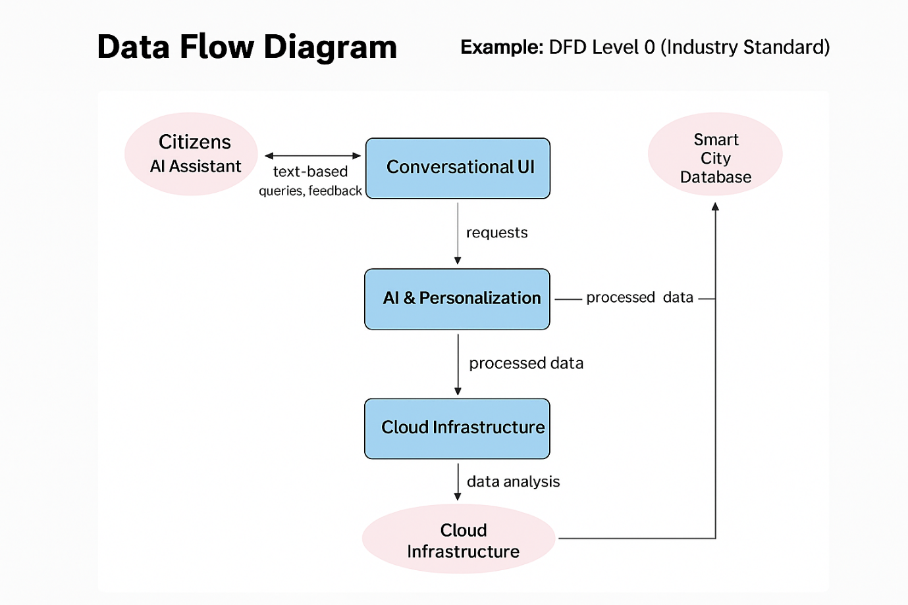

**User Stories:**

|  |  |  |  |  |  |  |
| --- | --- | --- | --- | --- | --- | --- |
| **User Type** | **Functional Requirement (Epic)** | **User Story Number** | **User Story / Task** | **Acceptance Criteria** | **Priority** | **Release** |
| Customer (Mobile user) | Registration | USN-1 | As a user, I can register using my email and password. | I can access my account/dashboard | High | Sprint-1 |
| Customer (Mobile user) | Registration | USN-2 | As a user, I will receive a confirmation email after registration. | I receive a confirmation email and can confirm | High | Sprint-1 |
| Customer (Mobile user) | Registration | USN-3 | As a user, I can register using Facebook. | I can register and access the dashboard via Facebook | Low | Sprint-2 |
| Customer (Mobile user) | Registration | USN-4 | As a user, I can register using Gmail. | I can register using my Gmail account | Medium | Sprint-1 |
| Customer (Mobile user) | Login | USN-5 | As a user, I can log in using my email and password. | I can access the dashboard after login | High | Sprint-1 |
| Customer (Web user) | Query Submission | USN-6 | As a web user, I can ask questions through the chatbot. | I receive real-time answers from the assistant | High | Sprint-1 |
| Customer Care Executive | Feedback Review | USN-7 | As a care executive, I can view feedback submitted by users. | I can view and categorize feedback | Medium | Sprint-2 |